**Analysis of Differences in Student Learning Satisfaction Levels Against ONLINE and OFFLINE Learning Faculty of Psychology UIN MALIKI Malang**

**Selly Candra Ayu, Muhammad Arif Furqon**

Faculty of Psychology, State Islamic University Maulana Malik Ibrahim Malang, Indonesia

[sellycandra@psi.uin-malang.ac.id](mailto:sellycandra@psi.uin-malang.ac.id), [mariffurqon@uin-malang.ac.id](mailto:mariffurqon@uin-malang.ac.id)

|  |  |
| --- | --- |
| **Article Information**  *Accepted :* **10 November 2021**  *Submitted :* **03 December 2021**  *Online Publish :* **20 December 2021** | *Abstract*  *This research aims to find out how much the level of difference in learning satisfaction to the online and offline learning process of the Faculty of Psychology UIN MALIKI Malang. Factors that affect learning satisfaction, namely: Tangible Aspects (Physical Evidence): Infrastructure Facilities, Teaching Media, Reliability Aspects (Reliability): Lecturer Reliability in teaching, Responsiveness Aspects: Lecturer Responsiveness, Assurance Aspects (Assurance): Lecturer's treatment of students and Empathy Aspect (Empathy): Understanding of student interests. This research was conducted on students of the Faculty of Psychology with a total of 134 subjects. Data collection tool in the form of a learning satisfaction questionnaire consisting of 40 items. Data analysis is carried out with the T-Test sample paired statistics technique, with the help of the SPSS statistics program version 28. From the results of the analysis of research data obtained correlation value 0.316. Based on the results of the analysis on this study, it can be concluded that there is a difference in student satisfaction of the Faculty of Psychology UIN Maulana Malik Ibrahim Malang between before the pandemic and at the time of the pandemic, both in the aspects of tangible, Reliability, Responsiveness, Assurance and empathy. Nevertheless, differences in satisfaction in Tangible aspects were not felt significantly between before and during the pandemic. This shows that students feel more satisfied studying online than offline.*  **Keywords: *Student Satisfaction; Learning; Online; Offline;*** |

**Introduction**

Learning starts from concrete to abstract, from simple to complex, and from easy to difficult. Students need to learn actively in various ways to construct or build their knowledge. A formula, concept, or principle in the subject should be built by students under the guidance of the teacher. Learning strategies need to condition students to find knowledge so that they are accustomed to conducting investigations and finding things (Dangnga & Muis, 2015)

According to (Bahri & Djumarah, 2002) "The success of education is influenced by changes and renewal of all components of education". Components that affect the success of education include curriculum, infrastructure, lecturers, students, and appropriate teaching models. All these components are interrelated in supporting the achievement of effective educational and learning objectives. The learning process is usually carried out in the classroom or outside the classroom and face to face. However, in early 2020 people around the world received information regarding the Covid-19 pandemic. In connection with the Covid-19 outbreak at the beginning of 2020, the Indonesian government then issued an appeal in accordance with the circular letter from the Ministry of Education and Culture of the Republic of Indonesia Number 3 of 2020 concerning Prevention of Coronavirus Disease (COVID-19) in the Education Unit and Letter of the Secretary-General of the Ministry of Education and Culture number 35492/A. A5/HK/2020 dated March 12, 2020, regarding the Prevention of the Spread of Coronavirus Disease (Covid-19) as well as following circulars and appeals from each Regional Government domiciled in Higher Education (Astini, 2020)

Based on this decision, the teaching and learning process is required to be carried out from home or what is called stay at home which will be held simultaneously in March 2020. Seeing these conditions, several education providers have started or switched from face-to-face methods to online learning methods. , by utilizing technology and internet media. The media used are Zoom, Google Classroom, Google Meeting, and Whatsapp (Marni, n.d.) Basically offline and online learning have something in common, namely whether there is interaction and communication between lecturers and students, but what makes the difference is the media used during the learning process. In offline lectures, lecturers and students are directly involved, while online lectures, lecturers and students communicate directly but are hampered by distance and sometimes there is interference related to signals, etc. Implementation of online learning is a challenge.

So many obstacles were found in its implementation. Not all regions in Indonesia have adequate internet network conditions. It is not uncommon to find students who have difficulty accessing online lecture platforms due to network conditions. In addition to network availability, the availability of supporting facilities and quotas also affects the online learning process. These obstacles affect the online learning process. Differences in conditions affect the ability of students to understand the material. This condition is still difficult to make students understand the material in its entirety. The online learning process is effective only in the assignment process (Maulana & Hamidi, 2020). Several obstacles and obstacles in online lectures certainly determine the extent of student learning satisfaction. Student satisfaction with the lecture process needs to be evaluated and becomes an important factor for higher education as a provider of educational services for students (Lala & Marhalim, 2019)

According to (Mulyapradana et al., 2020) Learning satisfaction has different meanings and meanings for each student, this change will certainly give a different response to students. All learning activities are carried out online. The level of student satisfaction is a determinant of the quality of the institution. For this reason, researchers want to find out more about the level of difference in student satisfaction with online and offline learning at the Psychology Faculty of UIN MALIKI Malang.

Metode

This research is quantitative research. Based on data collection techniques, including survey research. The questionnaires were distributed online via Google Forms. The research population is the students of the Psychology Faculty of UIN MALIKI Malang who have conducted offline and online lectures, namely in the 2017 2018 class, 2019 which is 659 students. The number of samples is determined by the Slovin formula, the description of which is as follows:

**N = 659**

**1 + 659 (0,1)2**

**= 99,8 (100)**

Respondents used in this study were 100 students. The questions given to the respondents used a 5-level Likert Scale. The data that has been collected was analyzed based on descriptive statistics. The data is presented in the form of graphs and then given a descriptive analysis in order to describe how the level of student satisfaction is.

Validity Test

A validity test is used to measure whether or not a questionnaire is valid. A questionnaire is said to be valid if the questions on the questionnaire are able to reveal something that will be measured by the questionnaire (Ghozali, 2006). This test is carried out using Pearson correlation, the guideline of a model is said to be valid if the significance level is below 0.05 then the question item can be said to be valid.

Reliability Test

A reliability test (consistency and stability of measuring instrument) was conducted to determine the extent of consistency of measuring instrument in providing measurement results. The reliability measurement used is Cronbach alpha. If Cronbach alpha > 0.6 then the construct is reliable (Sujarweni, 2014), so it can be said that the respondent shows consistency in providing answers to each questionnaire indicator.Uji Hipotesis Statistik

To obtain an overview of the characteristics, a description of the data for demographic variables was carried out. Meanwhile, to test the questionnaire in this study, it must meet two important requirements that apply to a questionnaire, namely valid and reliable, for that validity and reliability tests are used, and to answer the hypothesis proposed in this study using the Paired Samples T-Test statistical tool.

Result and Discussions

**Validity Test**

Validity test is a concept in evaluating test equipment that refers to the feasibility, meaningfulness, and usefulness of certain inferences that can be made based on the relevant test scores (Azwar, 2015, p. 10). The construct validity test in this study used the help of the IBM SPSS (Statistical Package or Social Science) version 28.0 for windows program.

Validity of Test Results on before the pandemic, based on testing the validity of the items on a satisfaction scale of learning before a pandemic by the number of 20 items tested on 100 subjects, there is the result that all items are valid and no items that fall with significant value ≤ 0.05.

Validity of Test Results in the current pandemic, based on testing the validity of the items on the scale of learning satisfaction after a pandemic by the number of 20 items tested on 100 subjects, there is the result that all items are valid and no items that fall with significant value ≤ 0.05.

Based on the results that all statement items that measure consumer satisfaction variables, all statement items are declared valid. This happens because the entire item statement generate significant value ≤ 0.05.

**Reliability Test**

A Reliability test using technique Alpha Cronbach by using the application program IBM SPSS (Statistical Package for Social Science) version 28.0 for windows.

Table 1. Test Results Reliability – Before Pandemic

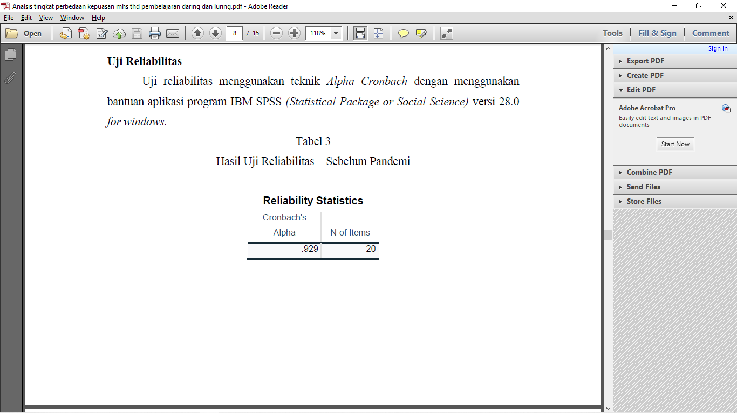

Source: spss output

The results of the reliability test on the learning satisfaction scale before the pandemic obtained an alpha value of 0.929 which is greater than 0.6 so that the results of this study can be declared reliable:

Table 2.Test Results Reliability – During a Pandemic

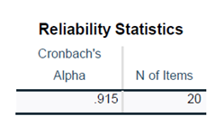

Source: spss output

The results of the reliability test on the learning satisfaction scale during the pandemic obtained an alpha value of 0.915 which is greater than 0.6 so that the scale and results of this study can be declared reliable.

Based on the results of the reliability test on the scale of this study, it can be declared reliable because the score results from both of them are greater than 0.6, namely on the scale before the pandemic the alpha value is 0.929 and on the scale after the pandemic the alpha value is 0.915. Therefore, it can be concluded that the scale has reliability or stability in the measurement process.

Table 3. Comparison of Statistical Test Results onaspects Tangible 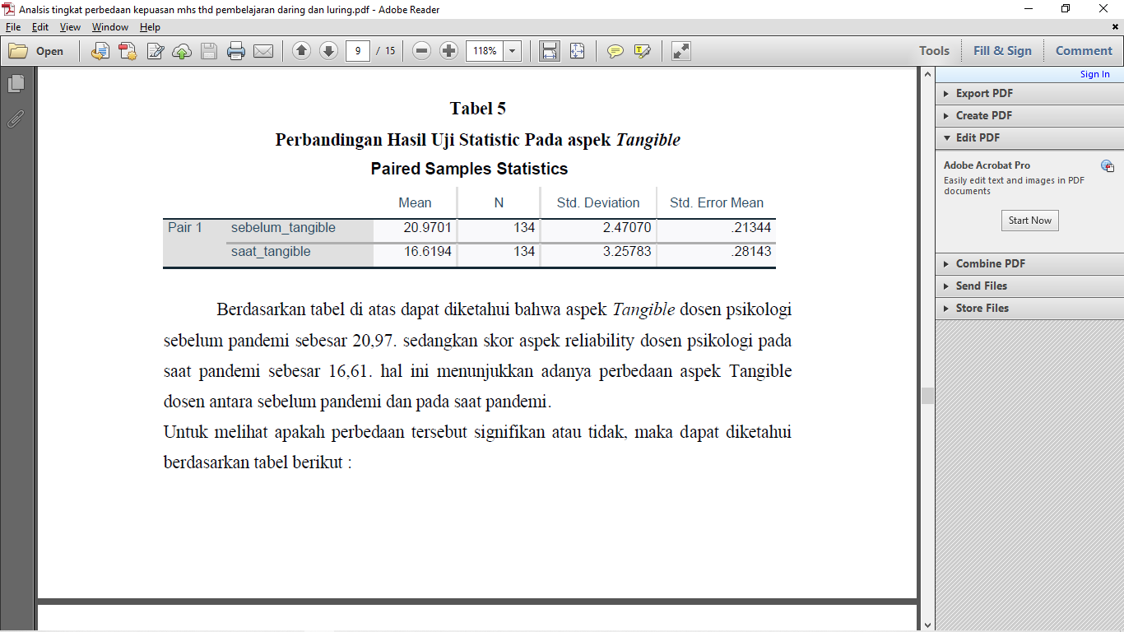

Source: spss output

Based on the table above, it can be seen that the aspect of Tangible psychology lecturers before the pandemic was 20.97. while the score of the aspect of Reliability psychology lecturers during the pandemic was 16.61. this shows that there are differences in the aspects of Tangible lecturers between before the pandemic and during the pandemic.

To see whether the difference is significant or not, it can be seen based on the following table:

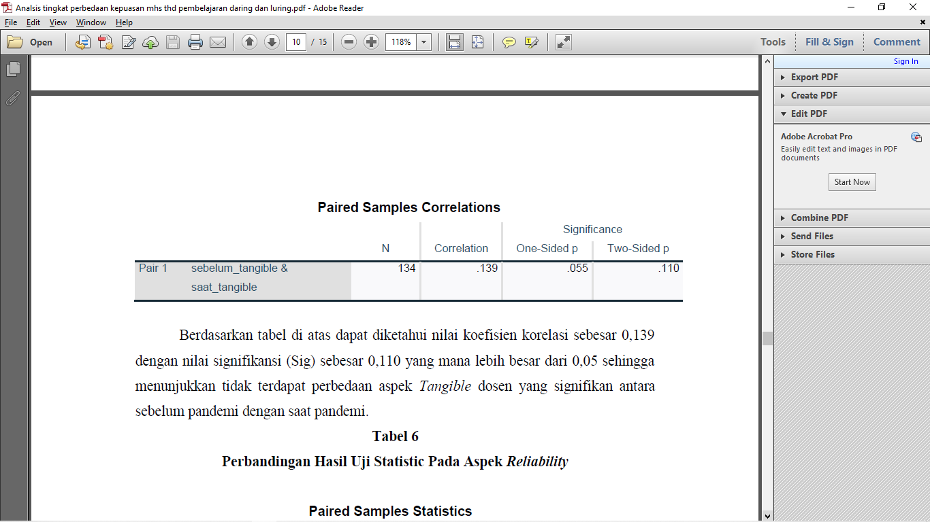

Source: spss output

Based on the table above, it can be seen that the correlation coefficient value is 0.139 with a significance value (Sig) of 0.110, which is greater than 0.05, indicating that there is no significant difference in theaspects of Tangible students between before the pandemic and during the pandemic.

Table 4. Comparison of Statistical Test Results on the Aspect of Reliability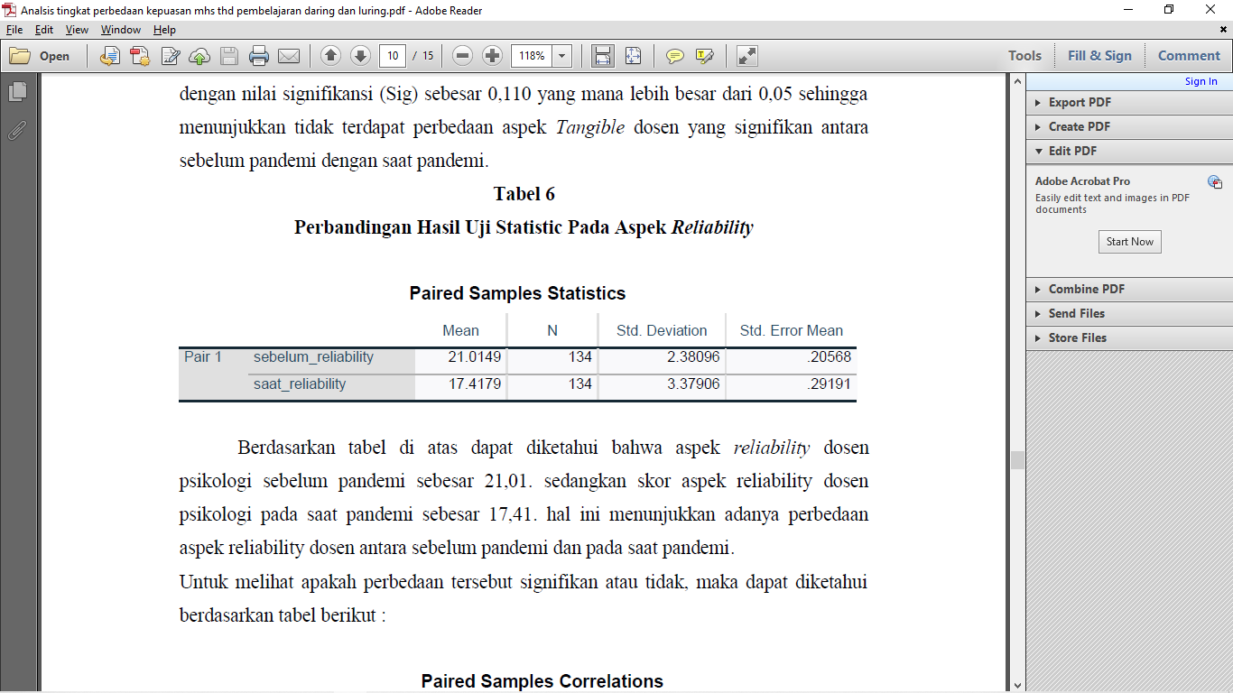

Source: spss output

Based on the table above, it can be seen that theaspect of reliability psychology lecturers before the pandemic was 21.01. while the score of theaspect of Reliability psychology lecturers during the pandemic was 17.41. this shows that there are differences in the aspect of reliability lecturerbetween before the pandemic and during the pandemic.

To see whether the difference is significant or not, it can be seen based on the following table:

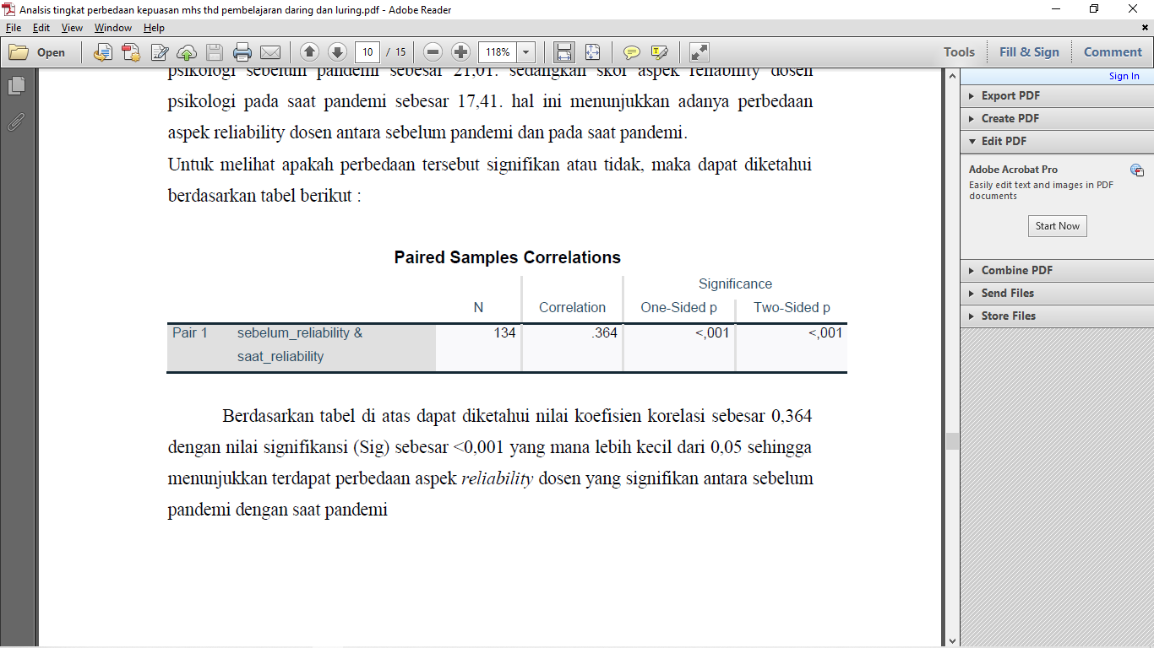

Source: spss output

Based on the table above, it can be seen that the correlation coefficient value is 0.364 with a significance value (Sig) of <0.001 which is smaller than 0.05, indicating that there are significant differences in aspects of reliability lecturer between before the pandemic and during the pandemic .

Table 5. Comparison of Statistical Test Results on aspects Responsiveness.

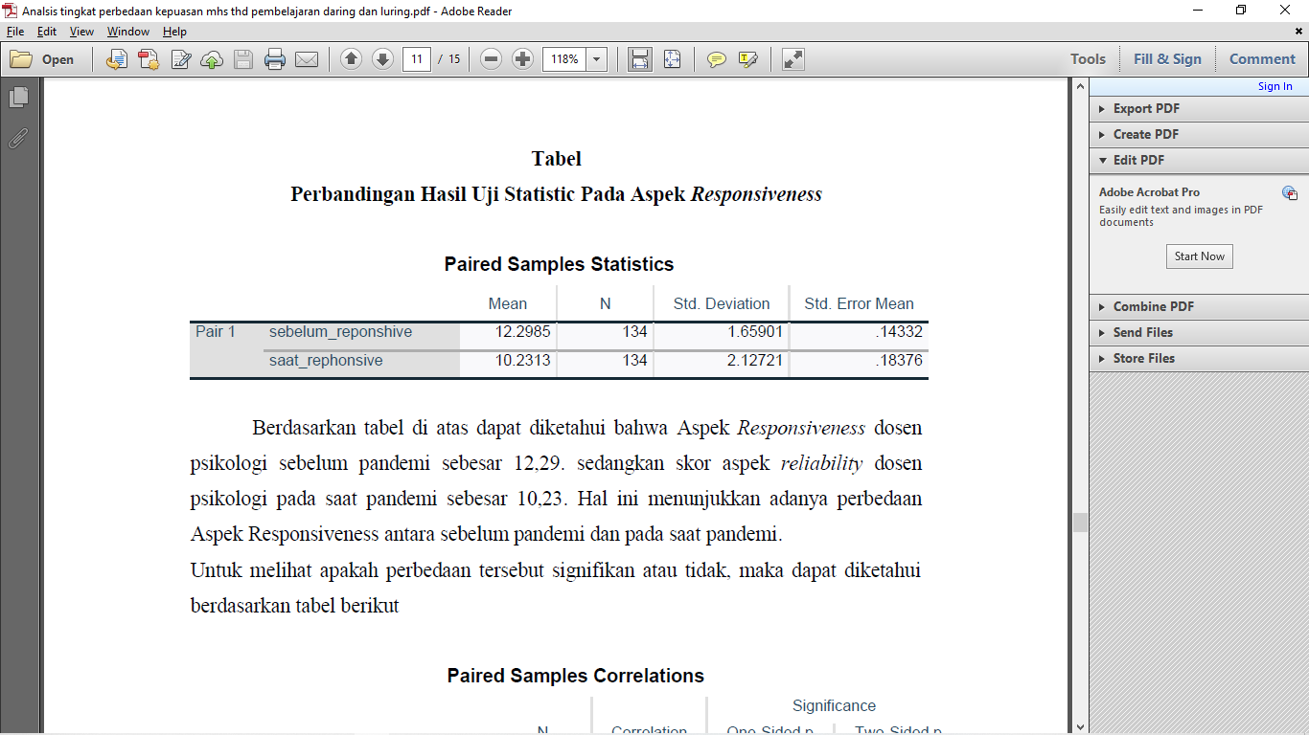

Source: spss output

Based on the table above, it can be seen that theAspect of Responsiveness psychology lecturers before the pandemic was 12.29. while the score of the aspect of Reliability psychology lecturers during the pandemic was 10.23. This shows that there is a difference in theAspect Responsiveness between before the pandemic and during the pandemic.

To see whether the difference is significant or not, it can be seen based on the following table:

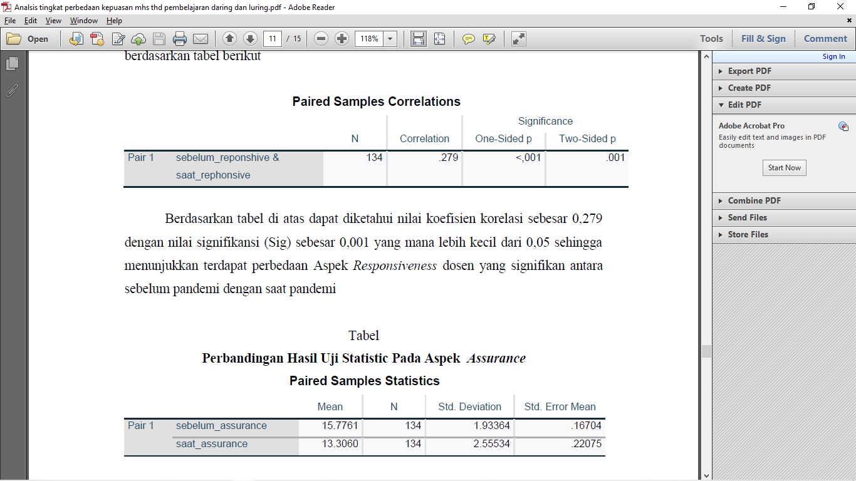

Source: spss output

Based on the table above, it can be seen that the correlation coefficient value is 0.279 with a significance value (Sig) of 0.001 which is smaller than 0.05, indicating that there is a difference in the aspect of Responsiveness significant lecturers between before the pandemic and during the pandemic.

Table 6. Comparison of Statistical Test Results aspects Assurance

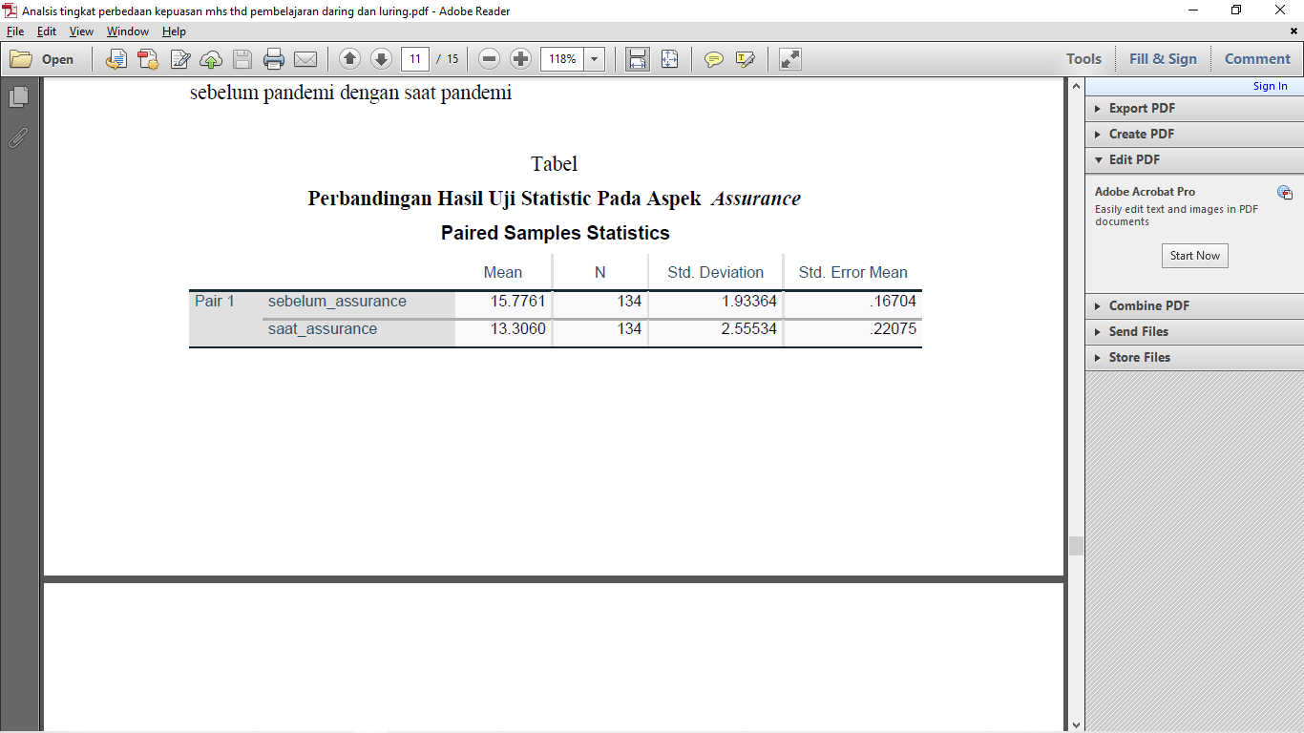

Source: spss output

Based on the table above, it can be seen that theAspect of Assurance psychology lecturers before the pandemic was 15.77. while the score of theaspect Reliability of psychology students during the pandemic was 13.30. this shows that there are differences inAspects Assurance between before the pandemic and during the pandemic.

To see whether the difference is significant or not, it can be seen based on the following table:

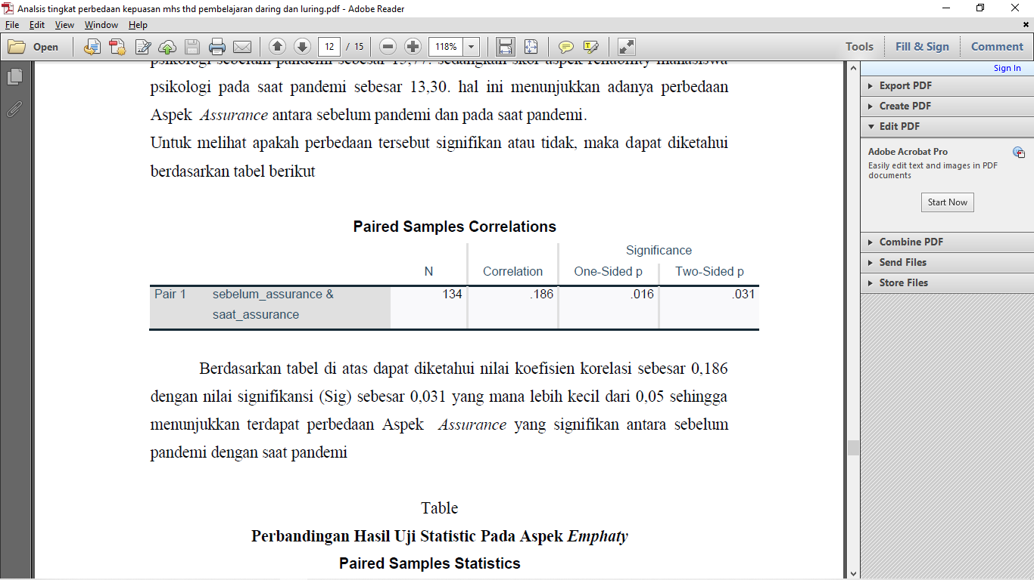

Source: spss output

Based on the table above, it can be seen that the correlation coefficient value is 0.186 with a significance value (Sig) of 0.031, which is smaller than 0.05, indicating that there are significant differences in aspects of Assurance between before the pandemic and during the pandemic.

Table 7. Comparison of Statistical Test Results on aspects Empathy

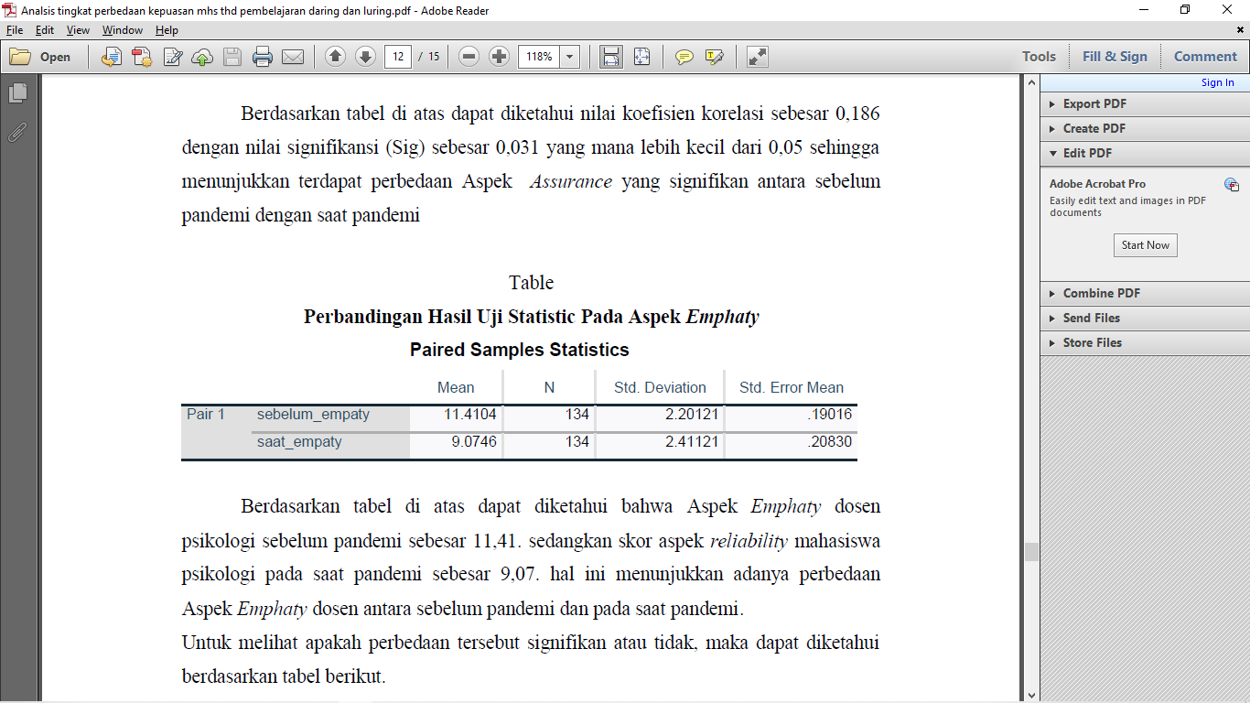

Source: spss output

Based on the table above, it can be seen that theAspect of Empathy psychology lecturers before the pandemic was 11.41. while the score of the aspect Reliability of psychology students during the pandemic was 9.07. this shows that there is a difference in theAspect Empathy lecturer between before the pandemic and during the pandemic.

To see whether the difference is significant or not, it can be seen based on the following table :

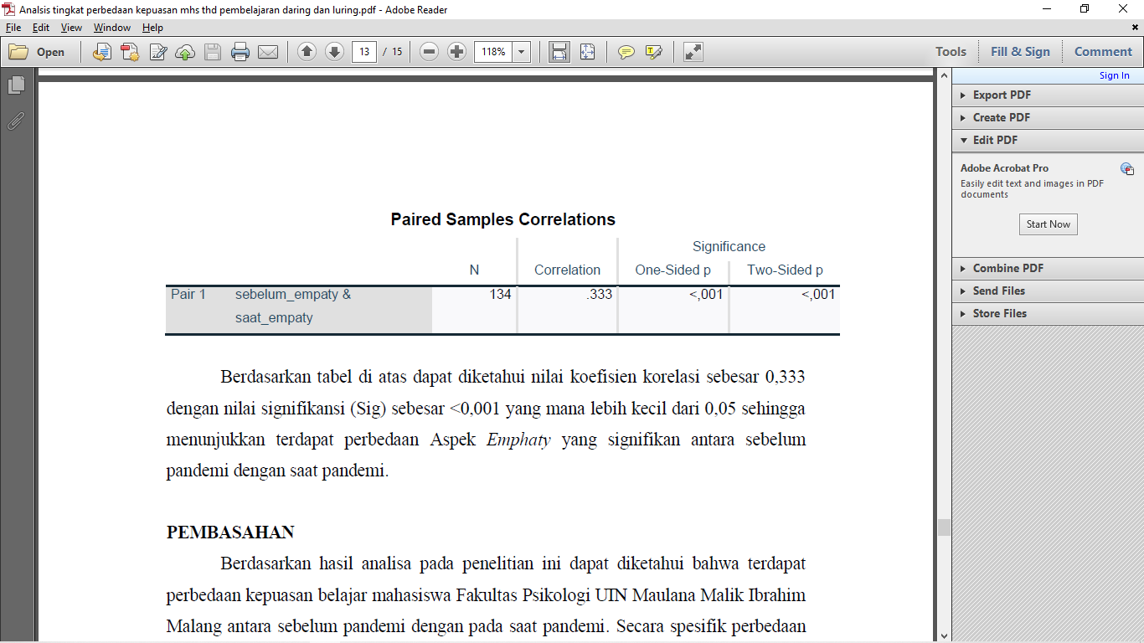

Source: spss output

Based on the table above, it can be seen that the correlation coefficient value is 0.333 with a significance value (Sig) of <0.001 which is smaller than 0.05, indicating that there is a significant difference in the Empathy Aspect between before the pandemic and during the pandemic.

Based on the results of the analysis in this study, it can be seen that there are differences in student satisfaction in the learning satisfaction of the students of the Faculty of Psychology UIN Maulana Malik Ibrahim Malang between before the pandemic and during the pandemic. Specifically, these differences will be explained based on the satisfaction aspects as follows:

1. Students of the Psychology Faculty of UIN Maulana Malik Ibrahim Malang had a Tangible aspect that was higher before the pandemic than during the pandemic, but this difference was not significant. This shows that the satisfaction of ownership, use and results of infrastructure and learning media before the pandemic was felt by students to be better than during pandemic
2. In the aspect of Reliability (reliability of lecturers in teaching) students felt that they were significantly higher before the pandemic than during the pandemic. The learning process before the pandemic was felt more optimally than during the pandemic
3. In the Responsiveness Aspect, the lecturers felt that the students were significantly higher before the pandemic than during the pandemic. This relates to the attitude, responsiveness and responsibility of lecturers to the subjects being taught.
4. In the aspect of Assurance (Assurance) lecturers perceived by students were significantly higher before the pandemic than during the pandemic. This shows that lecturers treat students feel better when lectures are carried out offline than when lectures are online

In the aspect of empathy, lecturers perceived by students were significantly higher before the pandemic than during the pandemic. This shows that lecturers' understanding of student interests is felt better when lectures are carried out offline than when lectures are online

**Conclusion**

Based on the results of the analysis in this study, it can be concluded that there are differences in student satisfaction in the learning satisfaction of the students of the Faculty of Psychology UIN Maulana Malik Ibrahim Malang between before the pandemic and during the pandemic, both in terms of tangible, reliability, responsiveness, assurance and empathy. However, the difference in satisfaction with the Tangible aspect was not felt to be significant between before and during the pandemic. This shows that students feel more satisfied learning online than offline.

**REFERENCE**

Astini, N. K. S. (2020). Tantangan Dan Peluang Pemanfaatan Teknologi Informasi Dalam Pembelajaran Online Masa Covid-19. *Cetta: Jurnal Ilmu Pendidikan*, *3*(2), 241–255.

Bahri, D. S., & Djumarah, A. Z. (2002). *Strategi Belajar Mengajar Jakarta: Rineka Cipta*.

Dangnga, M. S., & Muis, A. A. (2015). Teori belajar dan pembelajaran inovatif. *Makassar: Sibuku*.

Ghozali, I. (2006). *Aplikasi analisis multivariate dengan program SPSS*.

Lala, A., & Marhalim, M. (2019). Aplikasi Tingkat Kepuasan Mahasiswa Terhadap Layanan Administrasi Fakultas Teknik Universitas Muhammadiyah Bengkulu. *Pseudocode*, *6*(2), 172–180.

Marni, M. (n.d.). Challenges of Online Learning for Library Science Students. *Literatify: Trends in Library Developments*, *1*(2), 86–92.

Maulana, H. A., & Hamidi, M. (2020). Persepsi mahasiswa terhadap pembelajaran daring pada mata kuliah praktik di pendidikan vokasi. *Equilibrium: Jurnal Pendidikan*, *8*(2), 224–231.

Mulyapradana, A., Anjarini, A. D., & Harnoto, H. (2020). Pengaruh Kualitas Pelayanan Terhadap Kepuasan Pelanggan di PT. Tempo Cabang Tegal. *Jesya (Jurnal Ekonomi Dan Ekonomi Syariah)*, *3*(1), 26–38.

Sujarweni, V. W. (2014). *Metode penelitian: Lengkap, praktis, dan mudah dipahami*. Yogyakarta: Pustaka baru press.

|  |
| --- |
| **Copyright holder:**  Selly Candra Ayu, Muhammad Arif Furqon **(2021)** |
| **First publication right:**  KESANS : International Journal Health and Science |